LINUX BASIC COMMANDS ASSIGNMENT
1. Creating and Renaming Files/Directories
Commands :-
mkdir test_dir
touch exmaple.txt
mv exmaple.txt renamed_example.txt
Explanation :-
mkdir used to create directory
touch used to create a empty file
mv used to rename a file
Screenshot:-
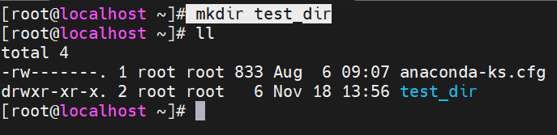
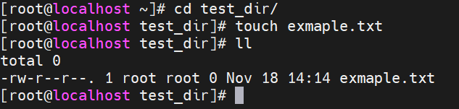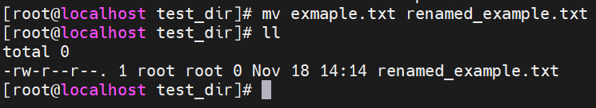
2. Viewing File Contents
Commands :-
cat /etc/passwd
head -n 5 /etc/passwd
tail -n 5 /etc/passwd
Explanation :-
cat used to view file contents.
Head used to view first lines of the file.
Tail used to view last lines of the file.
Screenshots:-
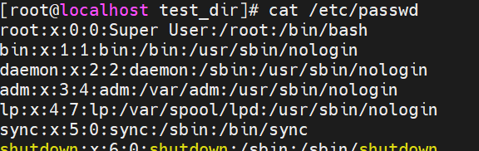
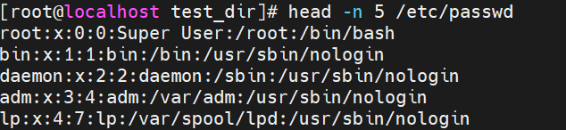
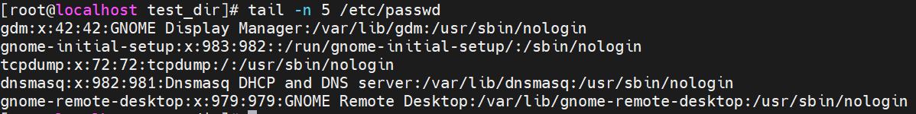
3.Searching for Patterns
Commands :-
grep "root" /etc/passwd
Explanation :-
grep searches for matching pattern.
Screenshot:-
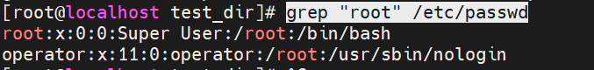
4. Zipping and Unzipping
Commands :-
zip -r test_dir.zip test_dir
mkdir unzipped_dir
unzip test_dir.zip -d unzipped_dir
Explanation :-
zip compresses a folder
unzip extracts file to specific directory
Screenshots :-
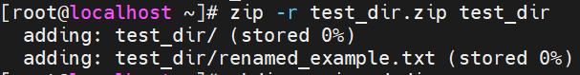
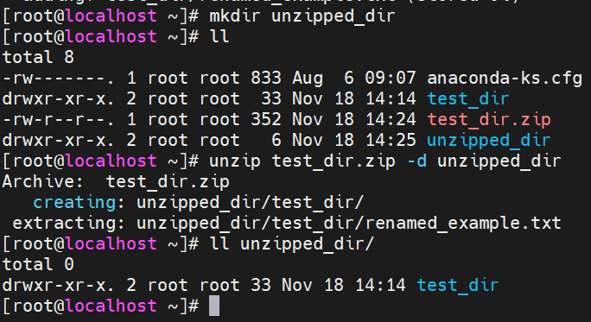
5. Downloading Files
Command :-
wget https://example.com/sample.txt
Explanation :-
wget downloads a file from the url.
Screenshot:-

6. Changing Permissions
Commands :-
touch secure.txt
chmod 444 secure.txt
Explanation:-
chmod 444 makes the file read only for everyone.
Screenshot :-
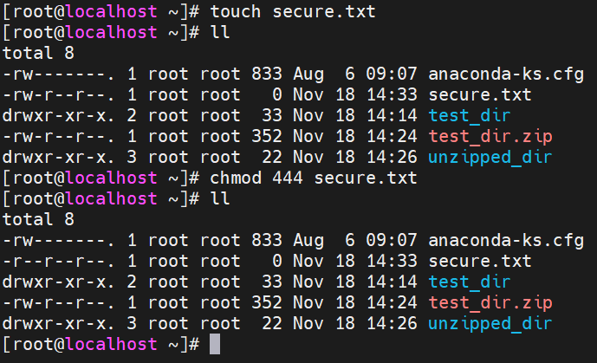
7. Working with Environment Variable
Commands :-
export MY_VAR="Hello, Linux!"
echo $MY_VAR
Explanation:-
exports sets a environment variable.
echo verifies it.
Screenshots :-
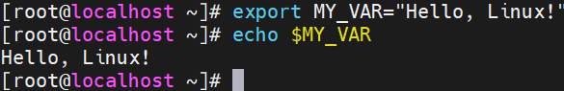

GitHub repo link :-
https://github.com/Raushik10/Assignment

